Cairo University,

Faculty of Engineering,

Computer Department.

Image Processing Project

Phase 1: Proposal""

**Team 2**

**Delivery Date** **:** Sunday 21-10-2018

**Team Members :**

1- Ahmed Salah

2- Khaled Sabry

3- Mahmoud Yossri

4-Mohamed Abd-Elaziz

***#Idea 1:-***

***Project overview :***

"MY EYE" will be an android app. Which mainly target blind people.

It will be an eye for them so, they can live like normal people.

They will be able to do what ever they want without any help but voice commands from the app.

***Inputs and Outputs:***

**Input :** Images from phone camera.

**Output :** Guide voice.

***Bloc Diagram :***

Currently , the phone camera will be the eye while the person is walking .the camera will perform some pre-pocessing on images it takes like **contrast enhancement , noise removal , ... .**

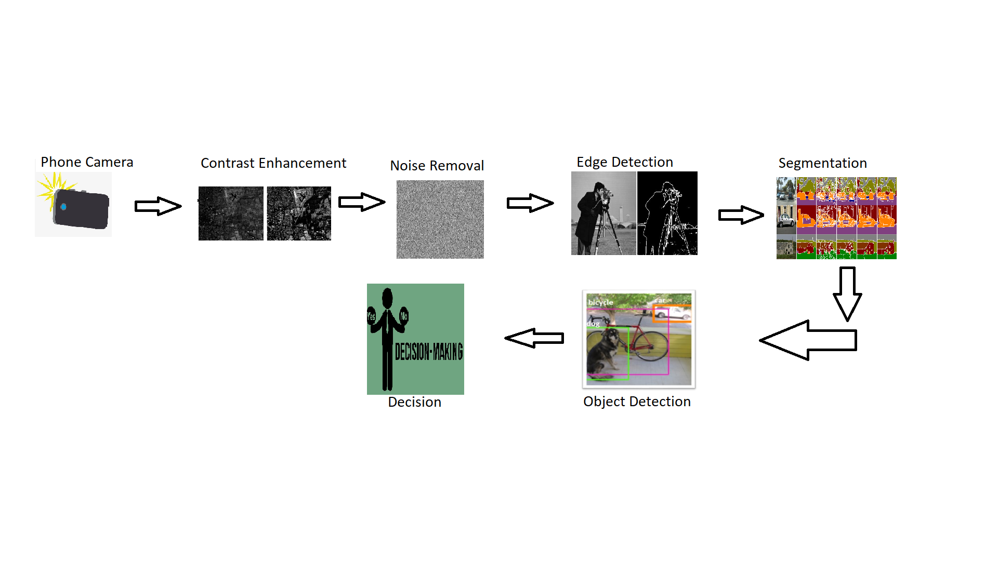

The processed image will then go through some neural network to identify the surrounding , measure distances and accordin to it the phone will make a guid voice to help the person.

***Open Sources :***

We will use just an **object detector –**most likely opencv**-**only to implement the step of object detection.

Each pre-processing step and also decission making will be implemented comletely by us.

***Stumbling Blocks :*** (uptill now)

1-The orientation of the phone. (may use var box for better vision)

2-What will happen if the battery is out of charge 0% and the person is alone.

3-How to deal with the lines between pieces of Ceramic.

4-Low light regions which may affect camera quality.

***Expected Deliverables :***

A complete working android application that help blind people to walk alone and avoid hitting objects.

***Future sight :*** (no delivery)

As shown above ,the app will help blind people to walk but **What Is Next?!**

We seek to make this app a real eye for the blind so in the future we will try to identify objects,recognise familiar faces , read articles , ... .

***#Idea 2 :-***

***Project overview :***

"High End Scanner" will be an android/windows app. Which mainly target is to take a photo from camera/hard disk about a document and then run it into processes so you get your text in a sharp and clear without noise in a page or the text or even you can change the color of the background for the page or for the text

***Inputs and Outputs:***

**Input :** Images from phone camera/hard disk.

**Output :** document with clear and sharp view.

***Development Process:***

Currently, the app will be developed on the computer for faster debugging and the photo will be run on different filters.

and we will provide an option for text change color and for background color.

***Open Sources :***

Actually, we didn’t choose any specific library but most of the work we will do by ourselves like filters and make it sharp and clear.

***Stumbling Blocks :*** (untill now)

1- what will we do if the image isn’t really a text image.

2- what will we do if the image isn’t rotated correctly.

***Expected Deliverables :***

A complete working android / windows application.

***Thank you!***